# Languages

Hebrew – Native language

English – Native language level

ORI BARAM – RESUME

My name is **Ori Baram**. I am a Junior Web Developer specializing in **full stack web development**.

I am well-versed in the following programming languages and technologies: **JavaScript, HTML, CSS, Sass, ReactJS, Redux, Node.js, Express, MongoDB**.

I am hardworking and dedicated, autodidact, eager to learn, develop and apply new technologies. Looking for my foothold in the world of programming. In the past year I have built many projects as part of my learning process.

**Phone:**

972 52 389 0224

**E-Mail:**

[obrm770@gmail.com](mailto:obrm770@gmail.com)

**LinkedIn:**

[www.linkedin.com/in/ori-baram](http://www.linkedin.com/in/ori-baram)

**Website:**

[www.ori-baram.dev](https://ori-baram.dev)

**GitHub:**

<https://github.com/obrm>

# Skill Highlights

* Self-disciplined
* Able to quickly learn new concepts and technologies
* Out of the box thinker
* Complex problems solver
* Creative thinker
* Responsible team-player
* Hardworking
* Able to work independently, to handle a development projects from start to finish.
* Committed and proactive
* Attention to details

# Technical Skills

* HTML5
* CSS3, CSS Grid, Sass
* JavaScript
* ReactJS, Hooks
* Redux, Thunk
* Reducers
* Node.JS, Mongo DB, Express
* Frontend & Backend
* SaaS

# Education

2000-2003

**Bachelor's degree, General Literature and Jewish Philosophy – Received the Dean's Honor,**

**Bar-Ilan University**

# Certifications

**Web Applications Development:** Appleseeds Academy & Microsoft, November, 2020.

**9 courses on Udemy in these fields of study:** JavaScript, HTML5, CSS3, ReactJS, Node.JS, Express, Mongo DB, UI/UX, Redux, Bubble.io.

# Experience

2020 till Now

**Built over 10 independent web projects as part of my programming studies**

* Visit my projects portfolio site - <https://www.obrm-portfolio.dev>

2020

**Built a full featured commercial SaaS web system for Greeneye company as a freelance**

* Used a no code tool called Bubble.io to build all by myself a full featured web system for Greeneye company for evaluating companies which are traded in the stock market.
* I planned, characterized, designed and built this project all on my own.
* Includes a full administrator interface and a client interface.
* [Visit the demo of project](https://greeneye-demo.bubbleapps.io/version-test)

2018 to 2020

**Information-systems support in Ra'anana municipality**

* Information-systems support, remote control, user training, troubleshooting information-systems issues, ongoing work with Active Directory.

2001 to 2005 and 2009 to 2016

**Client Backoffice Operations in the field of life insurance and pensions at various insurance companies**

* Ongoing care and management of pension portfolios and life insurance of companies.
* Ongoing work with Excel - analysis and processing of complex data - pivot tables, VLOOKUP, Macros, VB and other complex Excel functions.

2005 to 2007

**System implementation at Ichilov Hospital**

* Training, implementing, testing, characterizing, and giving technical support for the "Birth care" medical information-management system, in a variety of departments in the hospital.
* Administrator who handles authorizations, characterizations, version checks, etc.

PORTFOLIO - TOP 3 PRJECTS

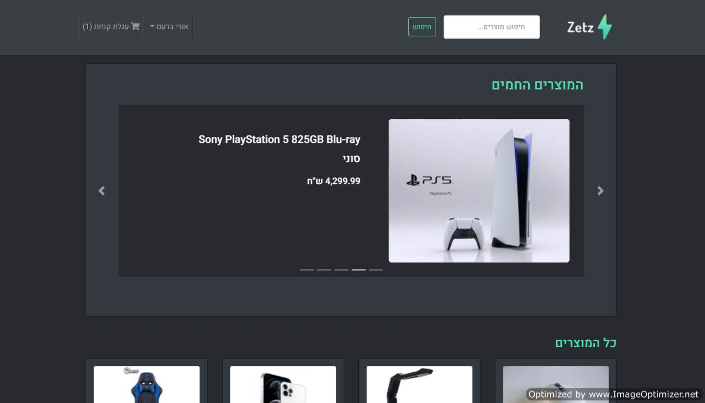

**Zetz Shop - eCommerce Platform Built With The MERN Stack**

**Technologies Used In The Project:**

React, Bootswatch, Redux, Node.js, Mongo DB, Mongoose, Express, Bcrypt, Json web token, Multer, Nodemon, Axios, Concurrently, Redux-Thunk.

**Features:**

Shopping cart, product reviews, top products carousel, pagination, product search, user profile with orders, admin product management, user & orders management, mark orders as delivered option, checkout process, PayPal / credit card integration and much more.

**The project was built as part of the course "**[**MERN eCommerce From Scratch**](https://www.udemy.com/course/mern-ecommerce/)**" in Udemy**

**[To Website](https://obrm-zetz-shop.herokuapp.com/)**

[**To GitHub Repository**](https://github.com/obrm/zetz-shop)

**Dev Home - A Social Network MERN Stack Application For Developers**

**Technologies Used In The Project:**

React, Redux, Node.js, Mongo DB, Mongoose, Express, Bcrypt, Json web token, Nodemon, Axios, Concurrently, Redux-Thunk**.**

**Features:**

A social network that includes authentication, profiles and forum posts.

**The project was built as part of the course "**[**MERN Stack Front To Back**](https://www.udemy.com/course/mern-stack-front-to-back/)**" in Udemy**

**[To Website](https://obrm-dev-home.herokuapp.com/)**

**[To GitHub Repository](https://github.com/obrm/dev-home)**

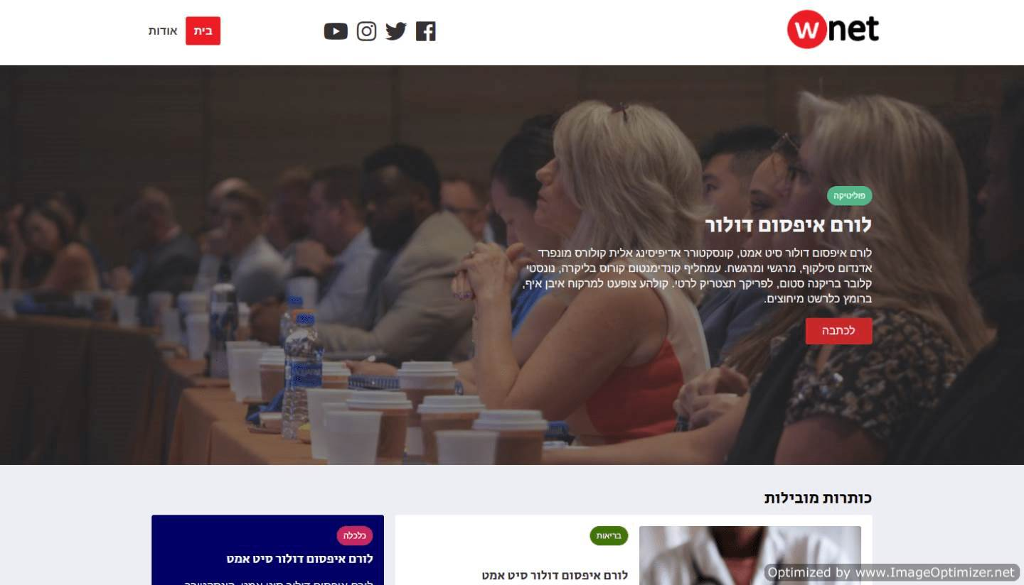

**wnet - CSS Grid News Site Template**

**Technologies Used In The Project:**

HTML, CSS, CSS Grid.

**Features:**

Pure CSS - No Libraries. Responsive.

**The project was built as part of the course "**[**Modern HTML & CSS**](https://www.udemy.com/course/modern-html-css-from-the-beginning/)**" in Udemy**

**[To Website](https://obrm.github.io/wnet)**

**[To GitHub Repository](https://github.com/obrm/wnet)**